2022-2023 DPAS Comp V Assessments

AMP/Schoology Assessment Pre- and Post- Tests
The following Comp V assessments will be administered via AMP/Schoology. Students will view questions and provide answers via Schoology therefore, no booklet is required.
- ELA
  - ELA Grades 6 – 12
- Math
  - Science Grades 6-8
Important: If an assessment is not listed, you can order test Booklets via DPAS using the directions below. Bubble Sheets will no longer be generated for Comp V assessments. All paper/pencil assessments will be hand scored then entered into a document to be uploaded to DPAS.

  - Calculus
  - Pre-Calculus
  - Geometry
  - Algebra I
  - Algebra II
- Science
  - Science Grade
  - HS Physical/Earth Science
  - HS Biology
  - HS Chemistry
  - HS Physics
- Social Studies
  - Social Studies Grades 6-8
  - Civics
  - Economics
  - US History
  - World History

Tasks and Timeline: Booklet Orders
Note: If the assessment is being administered via AMP/Schoology, you do not need to order booklets.
Task | Start | Finish
Pre-Tests: Beginning of Year  Note: Additional pre-test booklets will be generated as they are submitted throughout the year | 8/22/2022 | 9/16/2022
DSC activate Pre-Tests and Hide Post Test booklets on RC Print Shop | 8/22/2022 | 9/30/2022
Teachers order Comp V Assessments via DPAS | 8/22/2022 | 9/2/2022
Principals approve Teachers Work Orders | 8/22/2021 | 9/9/2022
DSC Submit Work Orders to Red Clay Print Shop | 9/5/2022 | 9/16/2022
DSC download obtain new assessment from DOE and load to RC Print | Ongoing | Ongoing
Red Clay or DSC Print shop print booklets and deliver to schools | Ongoing | Ongoing
Post Tests: 1st MP | 10/3/2022 | 10/14/2022
DSC automatically generate work orders | 10/3/2022 | 10/3/2022
DSC Print Booklets and Send to School | 10/4/2022 | 10/15/2022
Post Tests: 2nd MP and 1st Semester | 12/5/2022 | 12/16/2022
DSC automatically generate work orders | 12/5/2022 | 12/5/2022
DSC Submit Work Orders to Red Clay Print Shop (or print at DSC) | 12/5/2022 | 12/9/2022
Red Clay Print shop print booklets and deliver to schools | 12/5/2022 | 12/16/2022
Post Tests: 3rd MP | 3/3/2023 | 3/17/2023
DSC automatically generate work orders | 3/3/2023 | 3/3/2023
SC Print Booklets and Send to School | 3/6/2023 | 3/17/2023
Post-Tests: 4th MP, 2nd Semester, Full Year | 4/7/2023 | 4/28/2023
DSC automatically generate work orders | 4/7/2023 | 4/7/2023
DSC Submit Work Orders to Red Clay Print Shop (or print at DSC) | 4/10/2023 | 4/14/2023
Red Clay Print shop print booklets and deliver to schools | 4/10/2023 | 4/28/2023

Ordering Booklets
Important: Booklets only need to be ordered if they are not being administered via AMP/Schoology.
In DPAS, click on Order Internal Measure B Bubble Sheets | 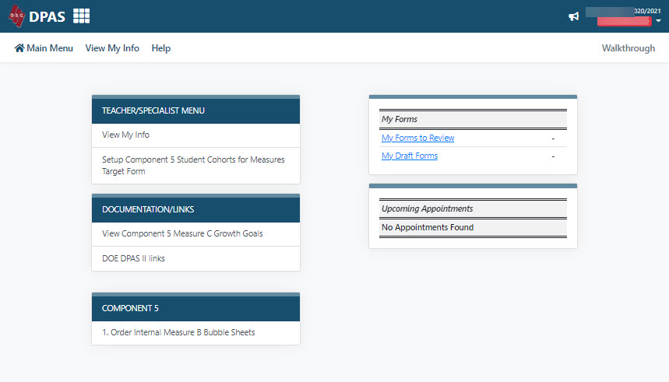
Click on the Add New button | 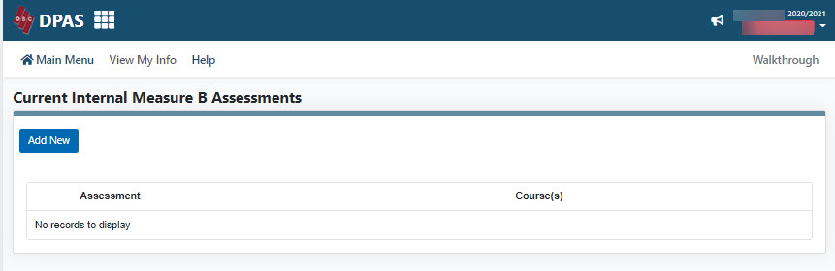
Select the following for the booklets you would like printed:  - Subject  - Grade  - Assessment  - Courses  Click the Save button  Repeat steps as needed  Note: Most High School Assessments are identified as 12th grade assessments. | 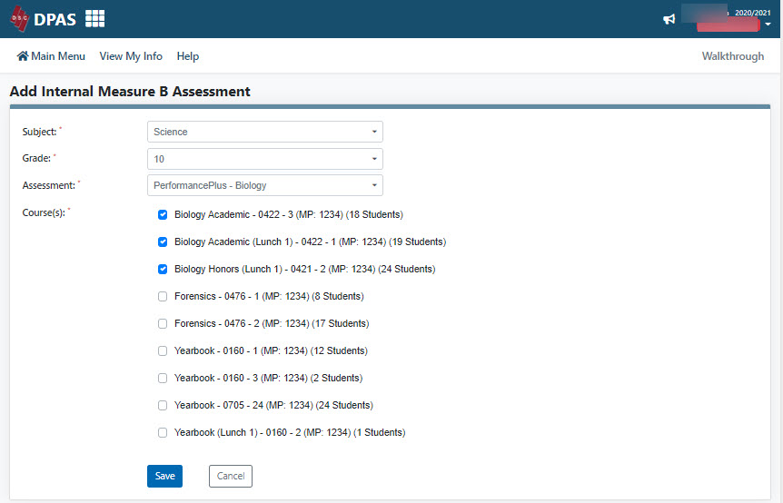
If you need to edit the order before your building administrator approves it, click on the Edit link. | 