JANUARY 2025
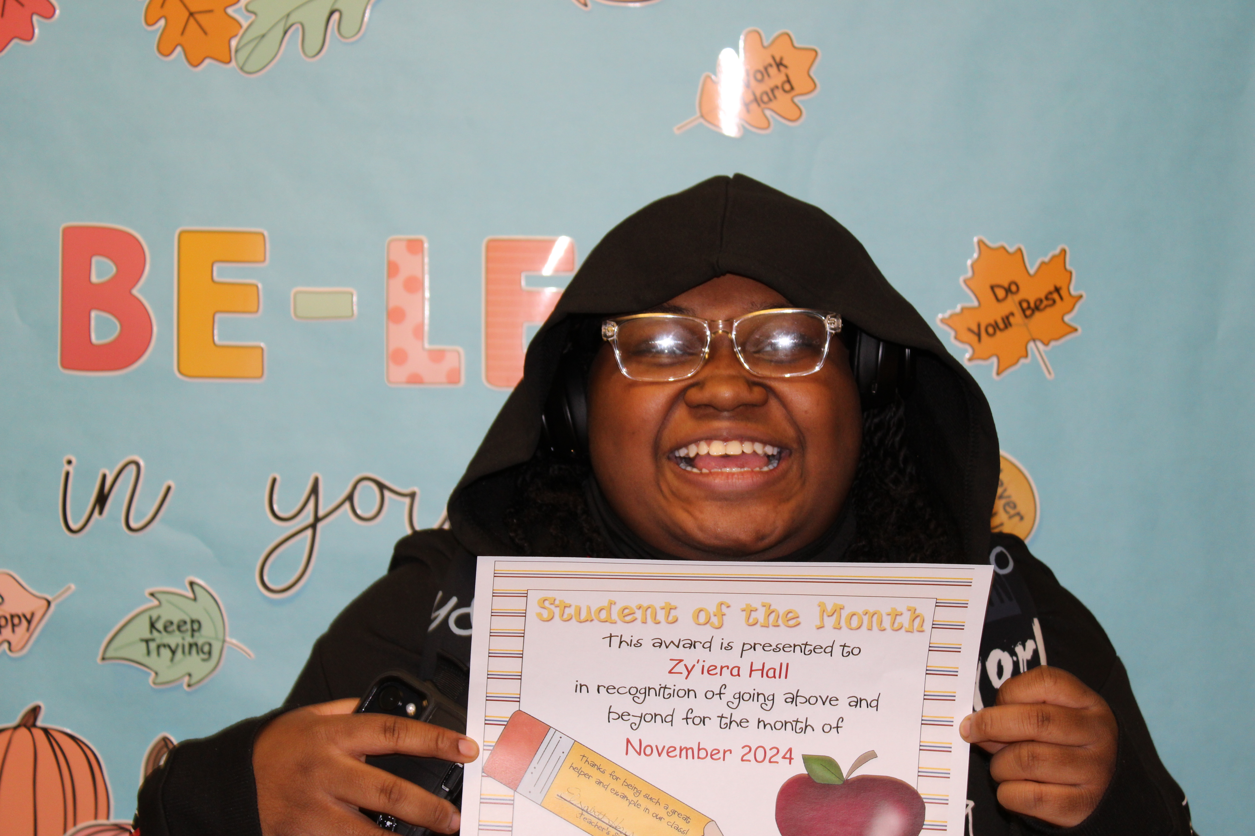
Zy’iera - November

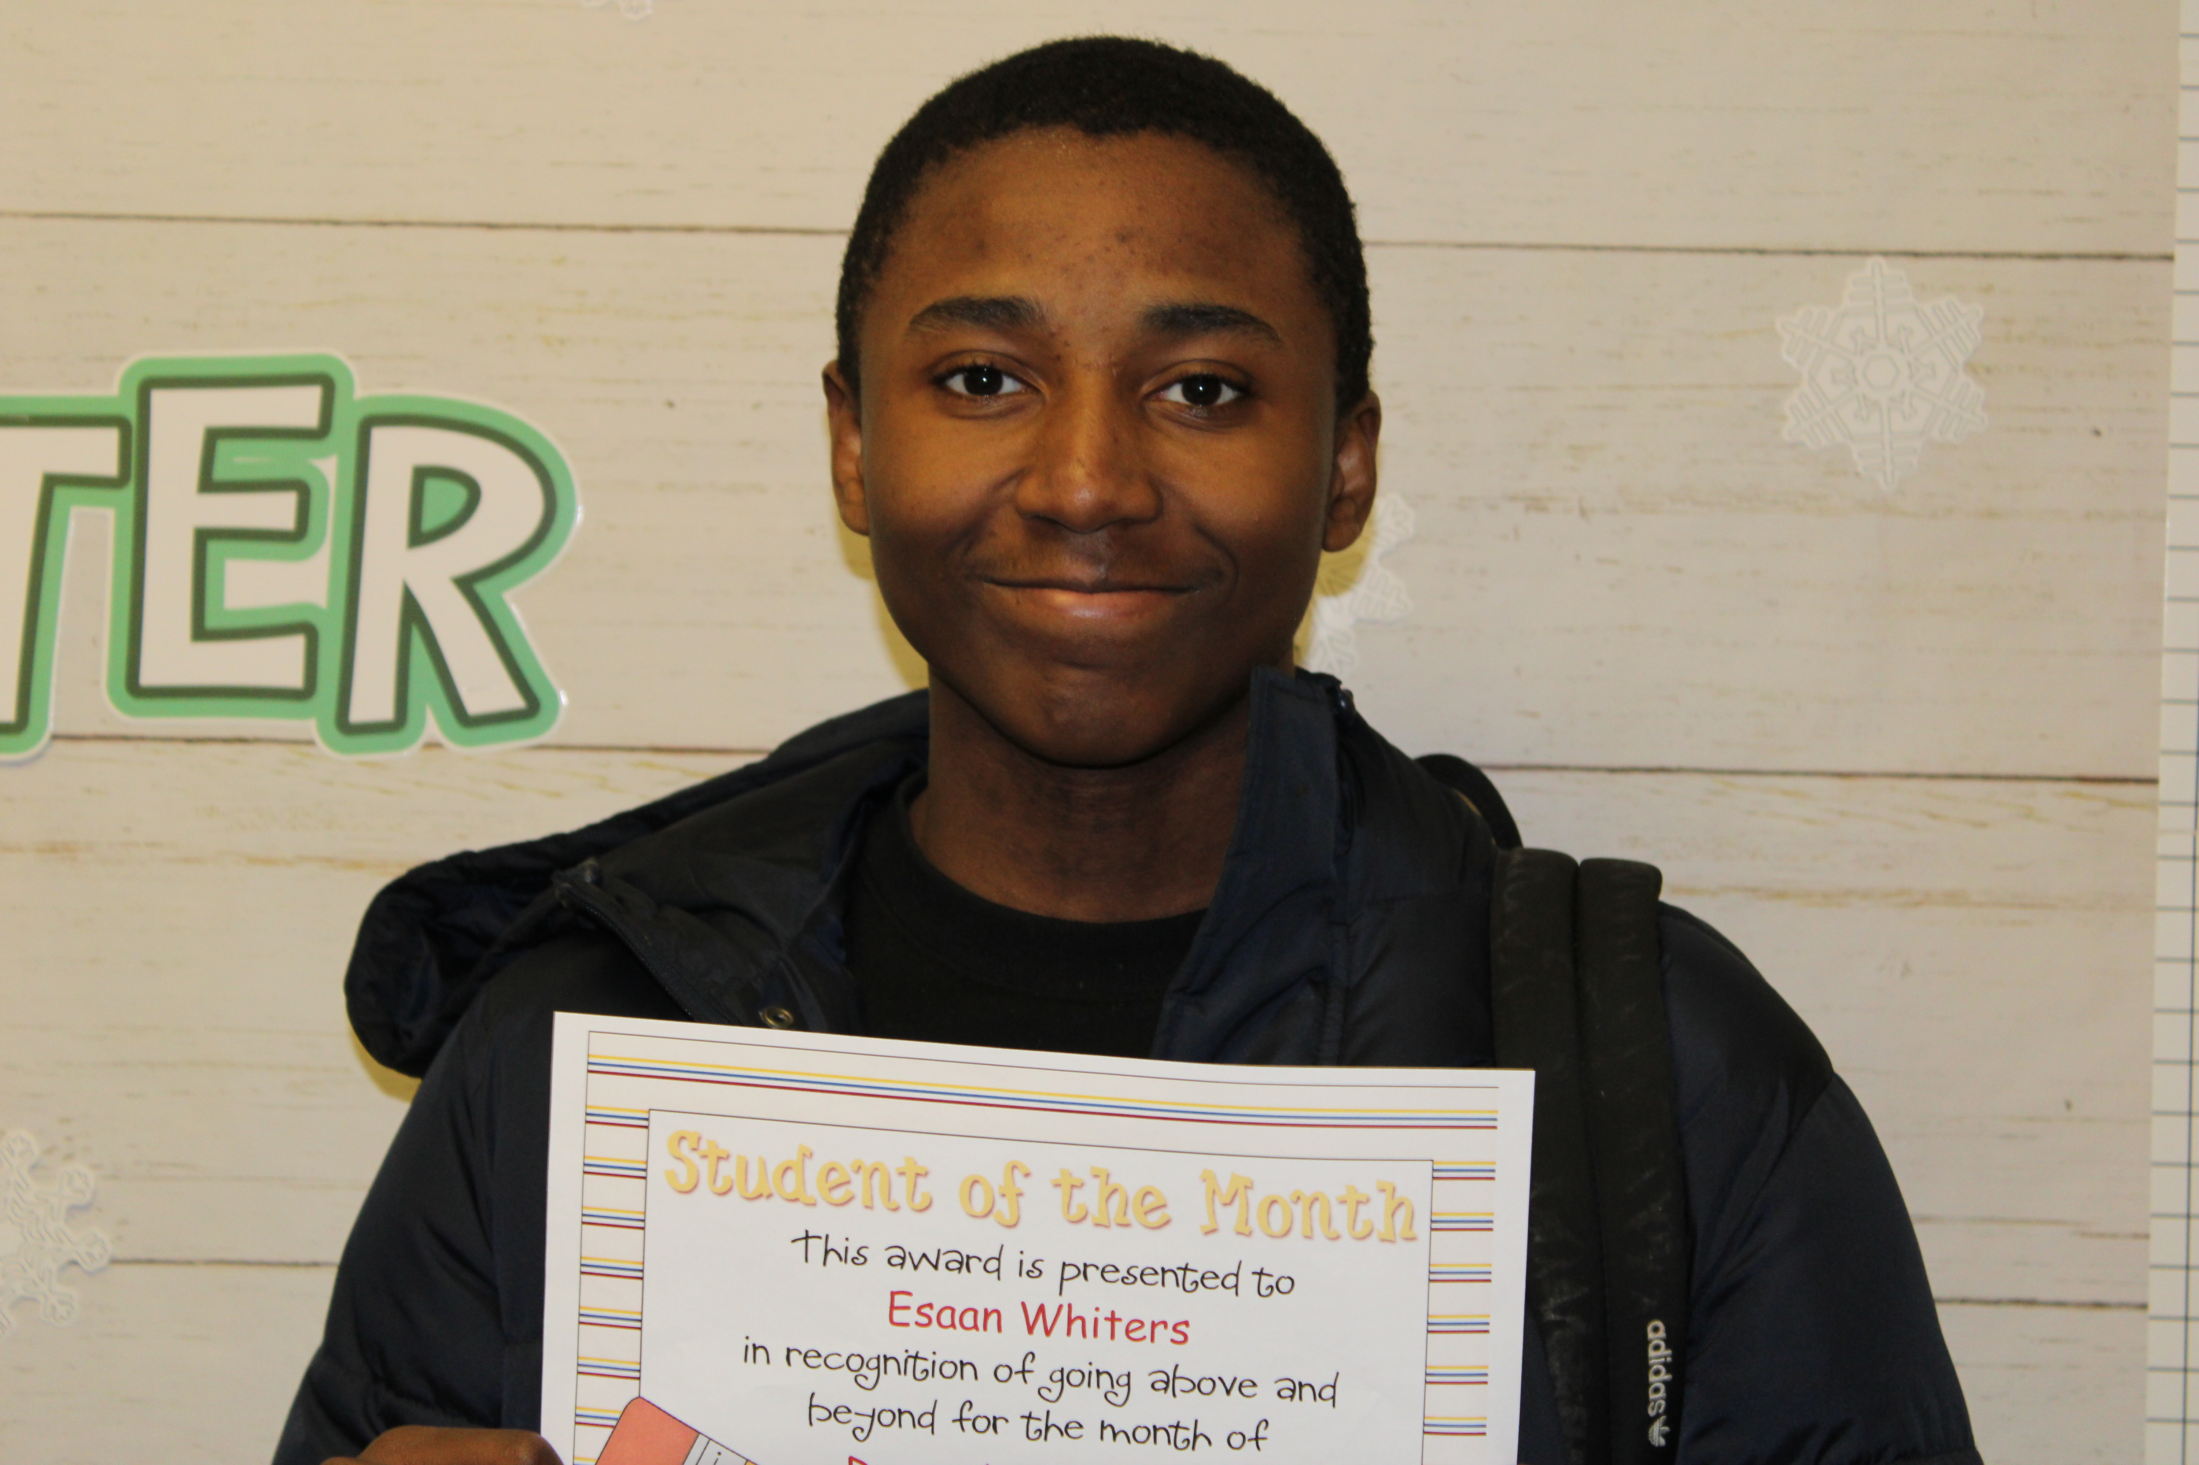
Esaan - December

Student of the month – nOVEMBER/DECEMBER
FIRST STATE SCHOOL 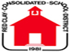 MONTHLY NEWSLETTER
MTSS (Multi-Tiered System of Support)
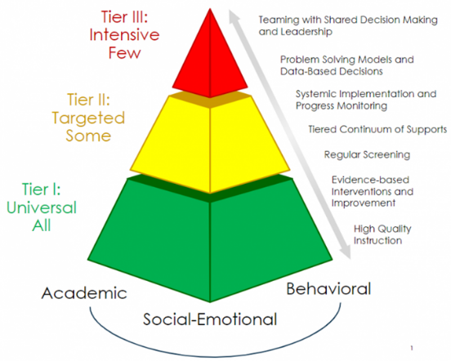
MTSS (Multi-Tiered Systems of Support) provides a framework of support using research-based strategies to help all students reach their fullest academic, social, and emotional potential.
Monthly Tier 1 events create a positive social environment for the school. Students purchase admission to these events using “FS Cash” which is earned in alll school settings by practicing our 3 R’s: Be Ready, Be Responsible, and Be Respectful!
In the month of January, students are learning how to be Ready, Responsible and Respectful in the Bathroom.
Ready: Have permission from your classroom teacher.
Responsible: Clean up after yourself.
Respectful: Knock and wait before entering the bathroom.
Important Dates:

January 9th: Overlook Café – Elementary
January 14th: School Store
January 16th: Overlook Café – Middle
January 20th: Schools closed
January 23rd: Overlook Café – High
January 24th: Schools closeed
January 30th: MTSS event- Movie at Penn Cinema

December's Event: Winter Wonderland
Students had a blast spending all of their FS Cash on donated toys, games, electronics, and personal items.

Upcoming Event: Movie Day at Penn Cinema
When: January 30th at 10:00 a.m. What: Moana 2 movie showing

